Suhana_CampusAudit

Campus Sustainability Assessment
Rajagiri College, Kalamassery — Photographic Site Audit

Methodology
This assessment is based on four photographs taken on-site at the college campus. Observations are limited strictly to what is visible in the images; no additional inspection, testing, or staff interviews were conducted. Where an interpretation goes beyond direct visual evidence, it is flagged as an inference rather than a confirmed fact.

Evaluation Focus
- Authenticity of observations — every issue below is tied to a specific photograph, with inferences explicitly separated from what is directly visible.
- Clarity and specificity — each entry states an exact location, who is affected, and a justified impact rating rather than a generic description.
- Relevance of issues identified — issues were selected because they reflect actual conditions in the photos (water stagnation, litter, fleet dependency, tree condition), not hypothetical campus-wide concerns.
- Effort in capturing real-world context — the report also credits existing sustainable practices (greenery, landscaping, the filter-bed structure) rather than only listing problems.

Sustainability Issues Identified
1. Stagnant Water in the Rooftop/Terrace Water Tank
Category: Environmental
Location: Elevated water storage tank/pond adjacent to the bamboo grove, near the main internal road
Observed: The tank holds dark green, murky water with visible algal growth. Dry leaves and organic debris have collected on the surface netting, with no visible movement, aeration, or overflow. There is no evidence in the photo of active water circulation.
Affected: Students and staff who pass the tank daily; indirectly, anyone on campus if the standing water becomes a breeding site
Estimated Impact: Medium
Recommendations:
- Set up a periodic desilting and leaf-skimming schedule (e.g. weekly) rather than relying on the surface netting alone
- Check whether the inlet/outlet system is functioning, since the lack of visible flow suggests it may be stagnant rather than actively circulating
- Introduce basic mosquito-control measures (larvivorous fish or periodic larvicide treatment) as a precaution, since standing water of this appearance is a plausible breeding risk even though no mosquitoes are visible in the photo
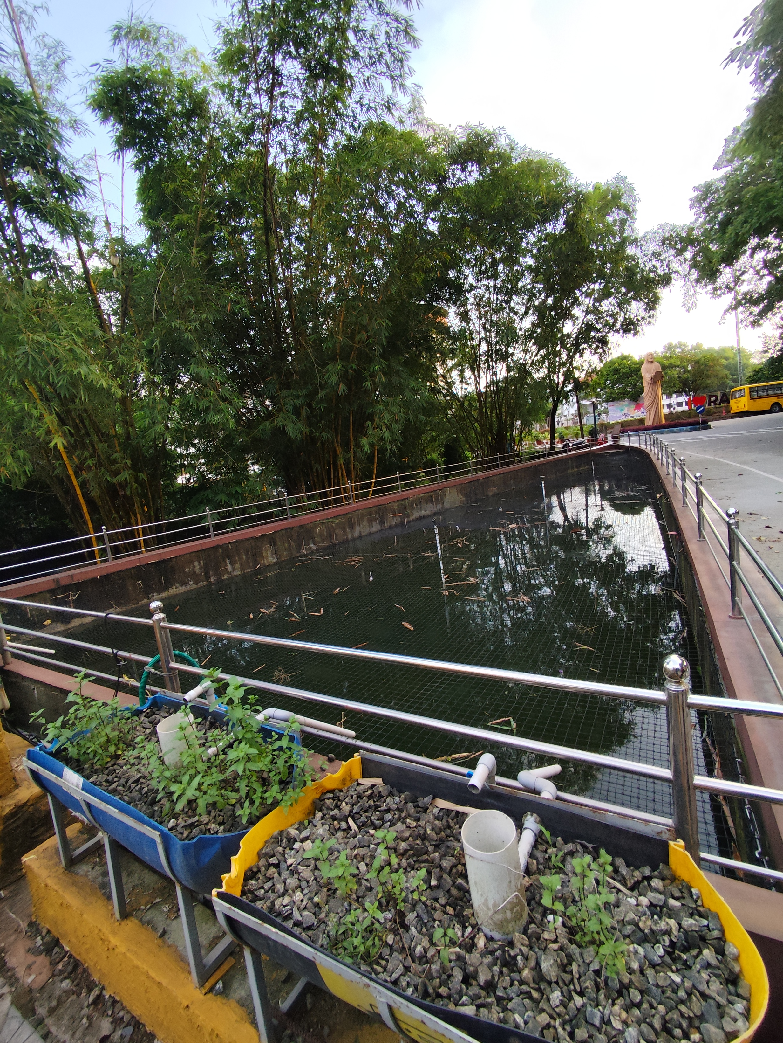
Photo 1 — Water tank showing algae growth, floating debris, and the adjacent gravel-bed filter planter
2. Diesel Bus Fleet and Uncollected Litter at the Parking Bay
Category: Environmental / Economic
Location: College bus parking area, near the "No Entry" signage and traffic cones
Observed: A row of large diesel-run buses (Rajagiri-branded and other private service buses) is parked in a dedicated bay. Scattered litter (small debris and wrappers) is visible on the paving between the buses. No exhaust or emissions are visible in the photo; the environmental concern here is about fuel dependency, which is an inference based on the vehicle type, not a directly observed emission.
Affected: Students and staff relying on bus transport; surrounding campus air quality over time (inferred, not directly observed)
Estimated Impact: Medium
Recommendations:
- Evaluate feasibility of phasing in electric or CNG buses for future fleet renewal
- Place waste bins near the parking bay and add it to the campus cleaning round, since the litter here appears uncollected
- Encourage carpooling or shared shuttle scheduling to reduce the number of vehicle trips where possible
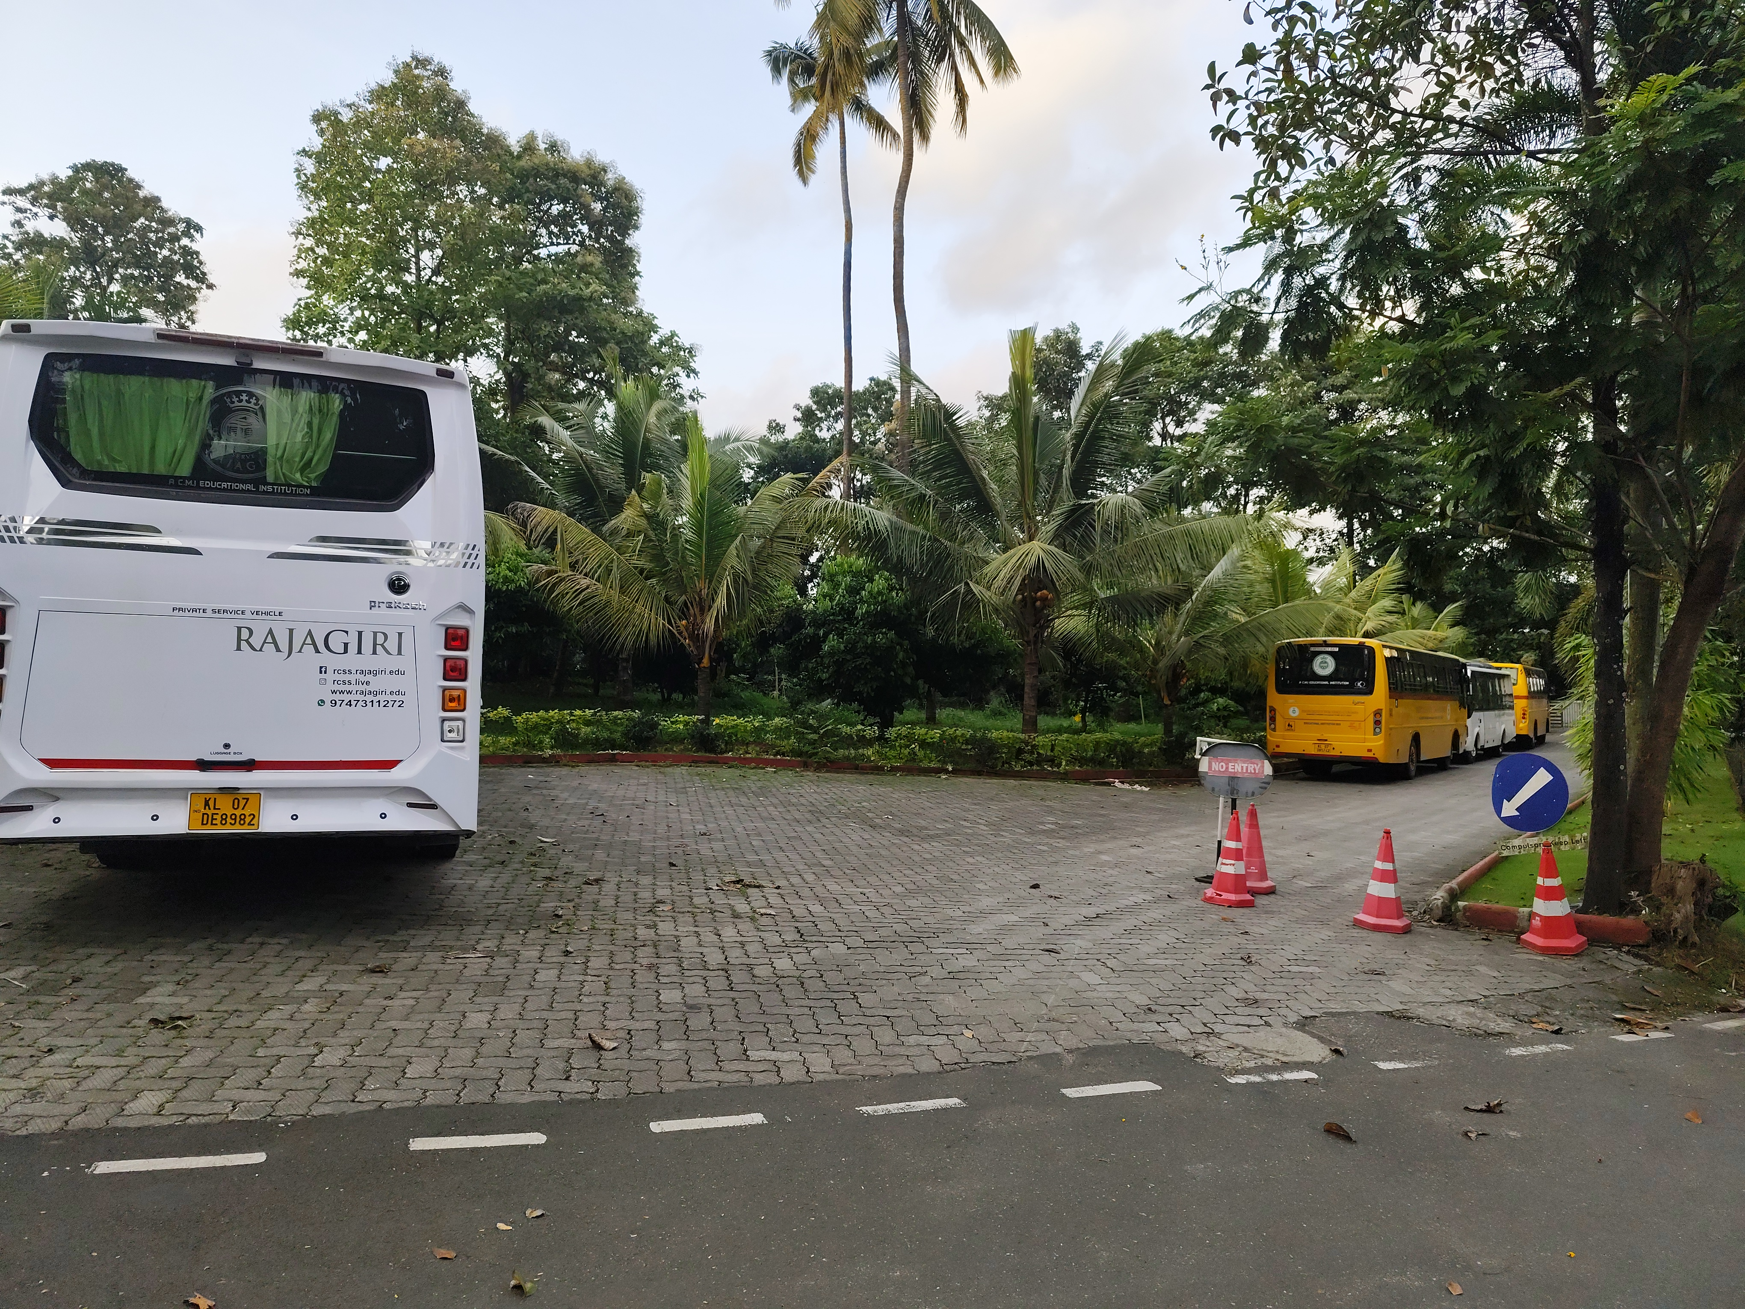
Photo 2 — Bus parking bay showing the diesel fleet and litter on the paving
3. Uncleared Organic Debris Under Fruit Trees
Category: Environmental
Location: Paved courtyard near the staircase, under the jackfruit trees (opposite the "Study in USA" banner)
Observed: Fallen jackfruit remains, dried leaves, and small debris are scattered across the paved walkway and have not been swept or composted.
Affected: Pedestrians using this walkway (minor slip/trip risk); general campus upkeep and appearance
Estimated Impact: Low
Recommendations:
- Route fallen fruit and leaf litter to a composting bin instead of leaving it on the pavement
- Increase frequency of ground-clearing in this specific courtyard during the fruiting season
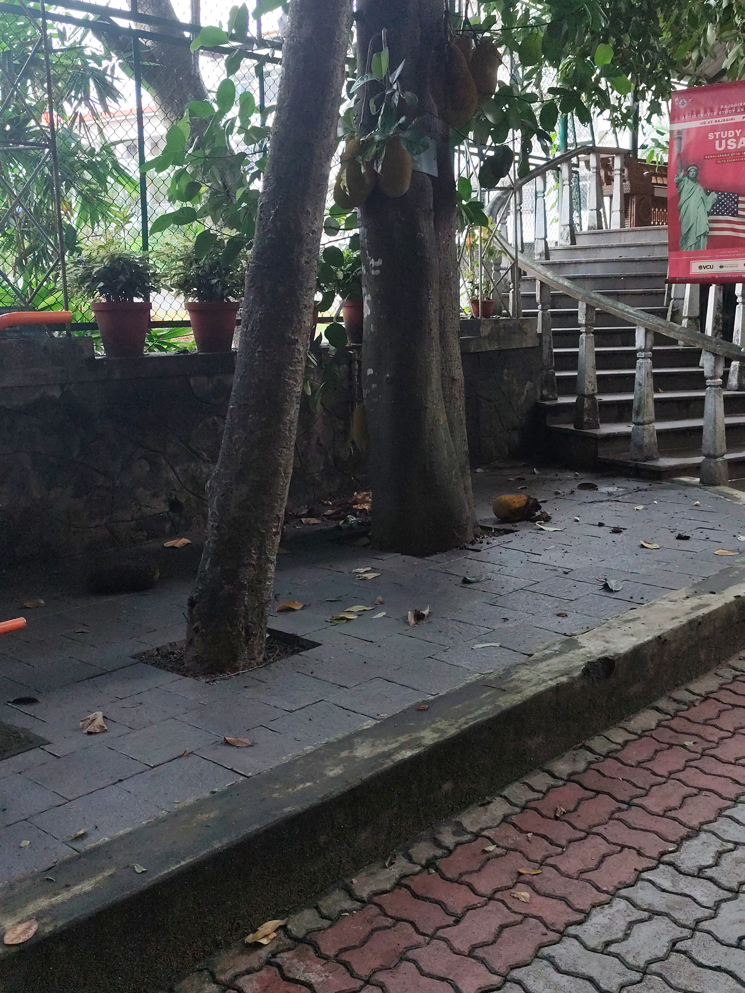
Photo 3 — Jackfruit courtyard with fallen fruit and leaf debris uncleared on the pavement
4. Tight Rope Support and Fallen Branch on a Garden Tree
Category: Environmental
Location: Landscaped garden bed behind the "NO PARKING" boundary wall
Observed: A mature tree trunk has a rope/cable wound tightly around it (appears to be a guy-line or restraint), and a broken branch is lying uncleared on the lawn nearby.
Affected: Long-term health of the tree; garden maintenance staff who will need to clear the branch
Estimated Impact: Low
Recommendations:
- Inspect whether the rope is girdling the bark and replace it with a broader, tree-safe strap if so
- Remove the fallen branch and check the tree for any structural damage that caused it to break
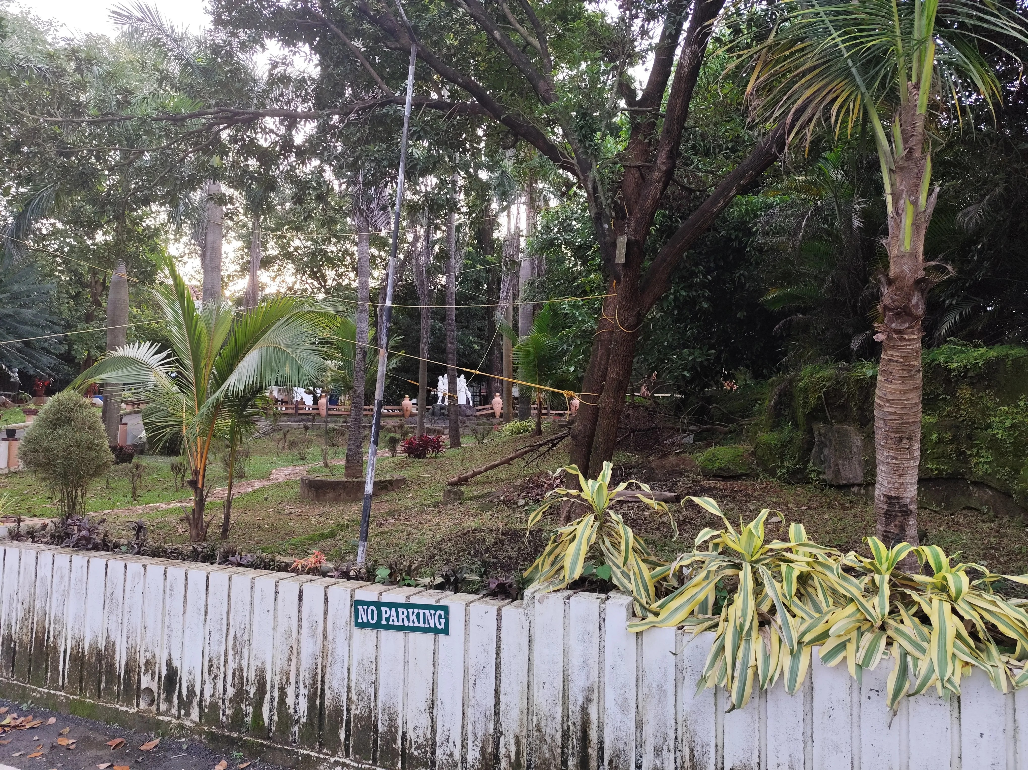
Photo 4 — Landscaped garden with tied tree trunk and fallen branch on the lawn

Positive Observations
- Dense bamboo grove and mature shade trees along the terrace/tank area contribute to green cover and campus microclimate.
- A small gravel-bed planter system with embedded PVC piping is installed right beside the water tank, consistent with a constructed wetland or bio-filtration setup for water treatment. Its plants look newly established and no water flow is visible in the photo, so it is not possible to confirm whether it is currently operational — but its presence itself reflects an intentional green-infrastructure investment.
- The garden area shows deliberate landscaping: a lawn, defined pathways, ornamental palms, and mixed planting (crotons, areca palms), indicating active groundskeeping.
- Potted ornamental plants are used along walkways and staircases, adding greenery to otherwise paved/built areas.

Conclusion
The campus shows clear investment in greenery and landscaping — bamboo groves, palm-lined gardens, and what appears to be a constructed wetland-style filter bed all point to sustainability being a deliberate design consideration rather than an afterthought. That said, upkeep is inconsistent: the water tank shows signs of neglect (stagnant, algae-laden, debris-choked), organic waste under the fruit trees and litter near the parking bay are not being cleared, and the transport fleet remains diesel-dependent. None of these are severe environmental hazards based on the photos alone, but they point to a maintenance and monitoring gap rather than a design gap. Addressing water circulation in the tank and instituting a regular litter/debris clearing schedule would be the most immediately actionable improvements.

